UNIVERSE
The vast boundless area around us is called the universe. There are many celestial bodies in this universe including the planets, stars, comets, satellites, meteors, meteorites, asteroids, etc. A group of many stars form a galaxy. Our Solar System is located in the Milky Way galaxy which is spiral in shape.
12.1 Importance of gravitational force in the universe
Due to gravitational force, the earth rotates about its axis as well as revolves in its orbit. Similarly, the moon and other celestial bodies in the universe. Gravitational force is also responsible for maintaining the distance and alignment of the planets in their orbits and making them revolve around the sun. Gravity is also the effect of gravitation.
12.2 Study of the Universe
Universe science is the branch of science that studies various facts about the universe including the history and future of the universe. One of its branches. Astrophysics, studies the origin, structure, and future of the universe.
Big-bang theory
Our solar system lies at a distance of about 30,000 light years from the centre of a spiral galaxy named the Milky Way galaxy having a diameter of about 100,000 light years.
The four fundamental forces existing in the universe: gravitational force, electromagnetism, strong nuclear force, and weak nuclear force are considered to have unified as a single force before the explosion. Therefore, in the first stage of existence, the universe is considered to be in a very compressed state in the size of a single atom.
Many theories about the origin of the universe have been proposed, among them, the Big Bang theory is considered the most reliable theory. According to the Big Bang theory, due to excessive force and pressure, a huge explosion of the atom took place and the universe originated from single atom (Big Bang). All celestial bodies in the universe are believed to have originated from this explosion.
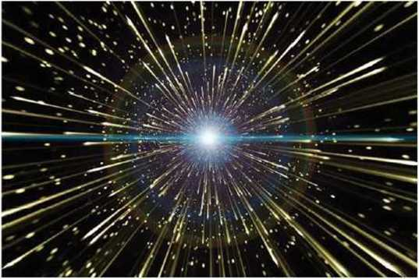

fig 12.3 Huge explosion of atom
All the celestial bodies are moving continuously far away from each other after the huge explosion of that dense atom. So, the size of the universe is also increasing day by day. But the speed of these bodies is decreasing due to the force of gravity.
Hubble’s studyIt has been discovered that the galaxies in space are moving away from each other. In 1929 BC. the American astronomer Edwin Hubble tried to calculate the velocities of various galaxies using the 100-inch Hooker telescope on Mount Wilson. During his research, he discovered that every galaxy is moving away from other galaxies. His estimation showed that the farther the celestial bodies are from the earth the smaller they appear and they also have a greater velocity.
He then plotted the velocities of the constellations against their distances on a graph and explained the relationship between the velocities of the constellations and their distances. This relation is represented by the equation v = Hd. and is known as Hubble's law. Here, v represents the velocity with which galaxies are moving away from each other, d represents the distance between them and H is Hubble's constant. The value of this constant is 73km/s/Mpc [Kilometer per second per Mega parsec]. This means, if any two galaxies are at a distance of one mega parsec, they are separating away from each other with a velocity of 73 km/s.
[1 parsec=3.086*10^16m=3.26 light years; 1mega parsec= 10^6 parsec]
If the distance between any two galaxies is expressed in parsec and then multiplied by Hubble's constant, the velocity with which these galaxies are moving away from each other is obtained. Based on the such calculation, we came to know the fact that the galaxies are moving very far away very quickly. It can also be known from Hubble's equation that the farther the galaxies are, the faster they are separating.
From this conclusion, just as every dot moves away from each other as the size of the air-filled balloon increases, the size of the area occupied by the entire universe is increasing. It is clear that the constellations in the universe are moving away from each other. Therefore, it can be assumed that they were close to each other in the past, which in turn means they were all at the same point a long time ago. Thus, Hubble's study helps to confirm the Big Bang theory.
12.3 Future of the Universe
All the galaxies in the universe are moving away from each other at a certain velocity and the size of the universe is increasing, but due to the gravitational pull of the masses in the universe, the velocity of all the galaxies is decreasing. As the distance between the bodies increases, the effect of gravity also decreases. Now the question remains whether the velocity becomes zero before the effect of gravity, the effect of gravity becomes zero before the velocity becomes zero, or both of them become zero at the same time. This determines the future of the universe. According to Newton's universal law of gravitation, gravitational force depends on the average density of the universe. The average density of the universe required to stop the expanding universe, which could be after billions of years, is called the critical density.
(a) Open universe
If the celestial bodies retain some velocity when the gravity becomes zero, they will then continue to move away from each other forever and the size of the universe will continue to increase. This situation is considered an open universe. If the average density of the universe is less than the critical density, then gravity cannot hold the expanding process and the universe which is continuously expanding now will continue to expand in the future too.
(b) Flat universe
If the gravity and the velocity of the celestial bodies become zero at the same time, the celestial bodies remain in the same position after that and the universe remains stable. Such a state is called a flat universe. If the average density of the universe is equal to the critical density, then the expansion rate of the continuously expanding universe gradually decreases and finally stops. Till then, there will be an infinite distance between each celestial body because of this they will not be affected bv mutual gravitational force. Such universe is called flat universe.
(c) Closed universe
If the gravitational effect remains nonzero when the speed of the celestial bodies becomes zero, the celestial bodies will start to come closer and the universe will come to a single point. The phenomenon in which the vast universe filled with unlimited mass and energy will at one point shrink and collapse is called the Big Crunch. If this happens, the universe created by the explosion of a single point will end up being a point and explode again to form a new universe like the present one. Such universe is called closed universe.

